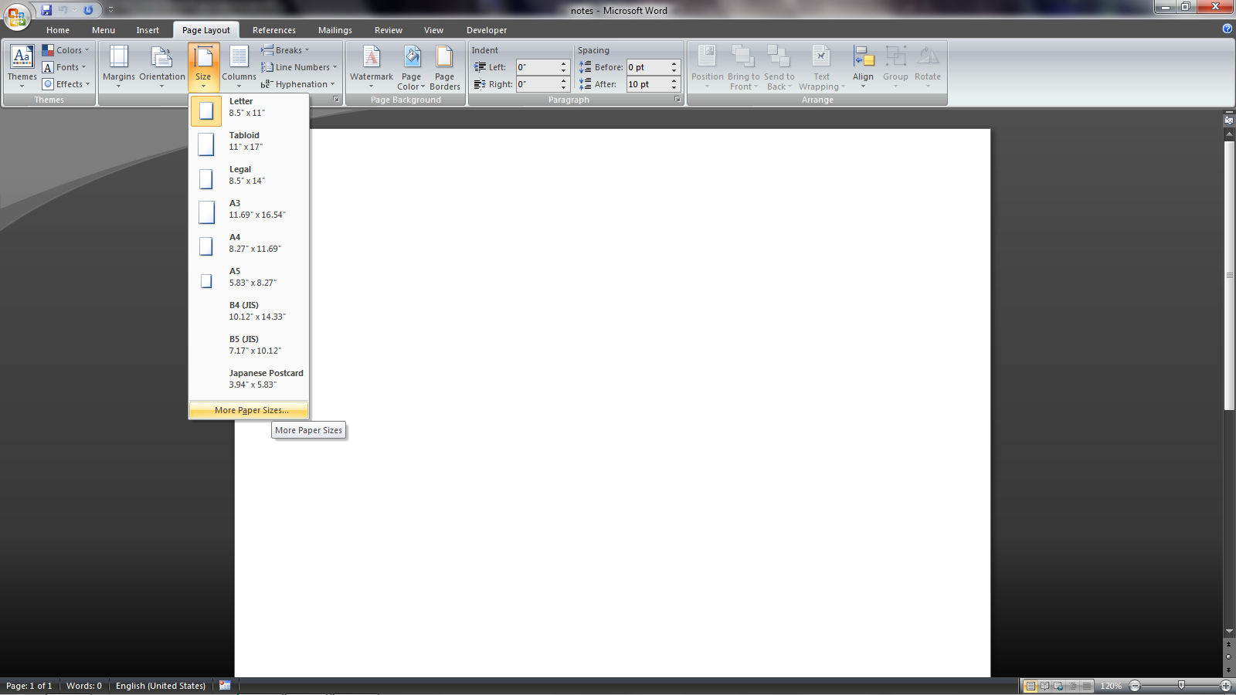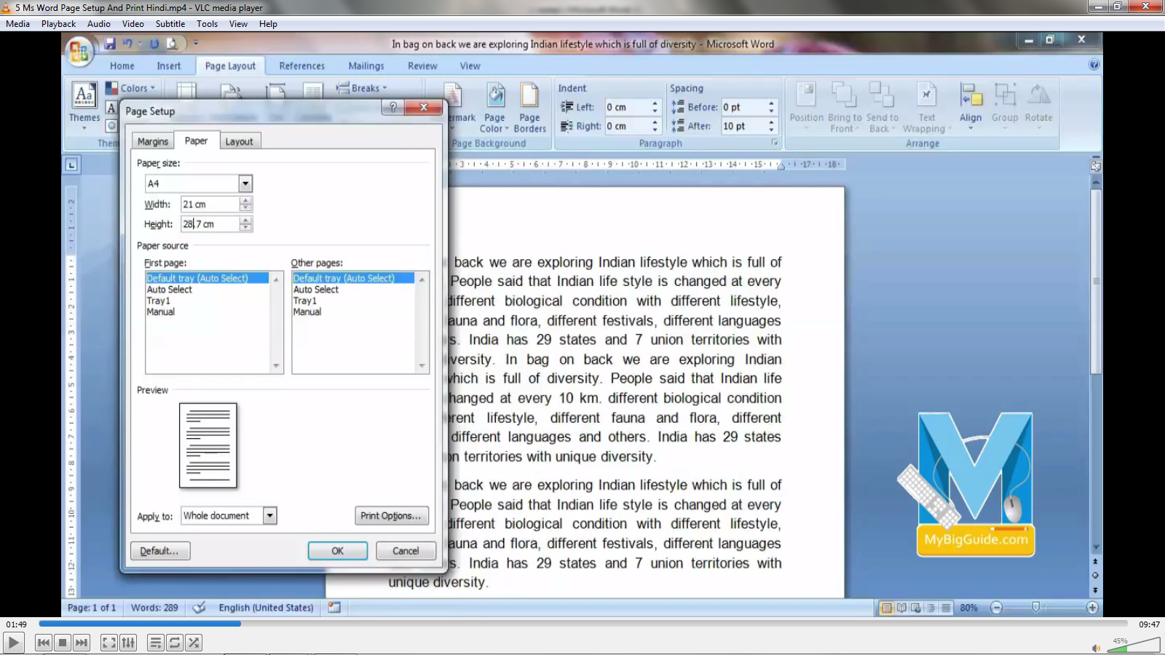A4 page size in Microsoft and real A4 have different sizes as in PC it size is according to US while in India A4 size is slightly so we have to make above changes in size

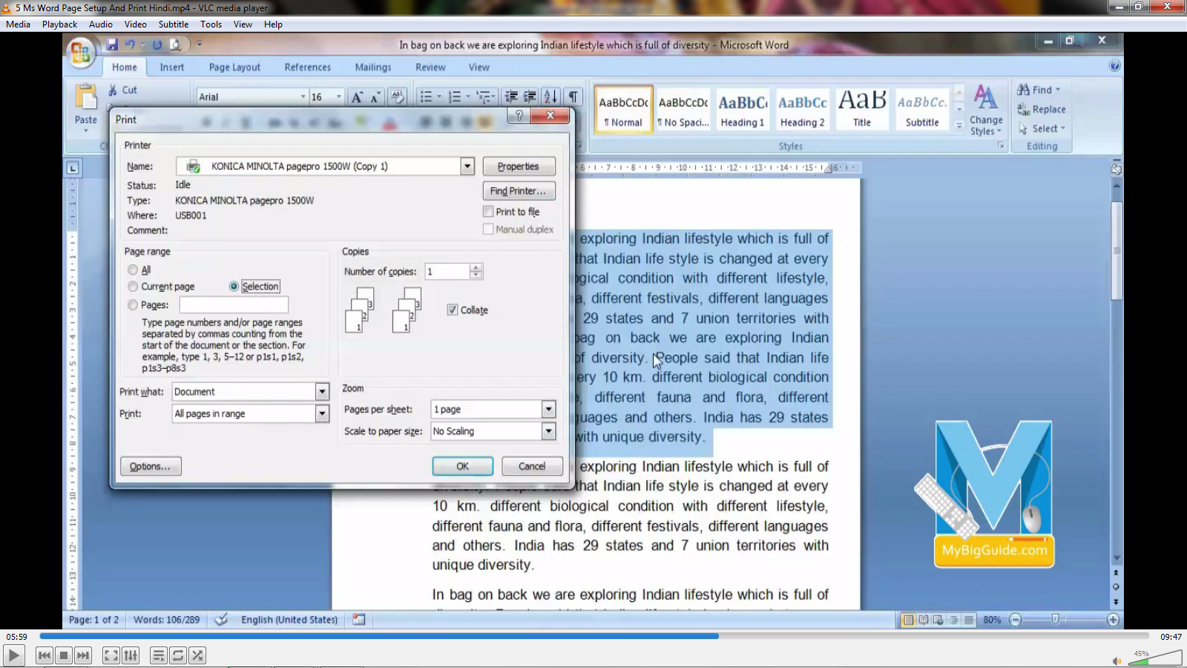In this way only selected portion will be printed

